List of stereotye to categorize subProfiles ShortCircuit Description Operation European Abstract Entsoe

Concrete Classes

MessageDocumentHeader
[0..1]
MessageDocumentHeader
Acknowledgement_MarketDocument
[0..1]
MarketDocument
The envelope entity is a non-CIM object used in an energy data space environment to serve as a central top-level entity connecting the MarketDocumentHeader (energy data space specific context information block) with the regular CIM MarketDocument.

Native Members
Acknowledgement assembly model
Acknowledgement_Envelope

Acknowledgement_MarketDocument Acknowledgement assembly model
An electronic document that is used to acknowledge the reception of a document and to provide information concerning its basic validity.

Native Members
createdDateTime | 1..1 | ESMP_DateTime | The date and time of the creation of the document.
mRID | 1..1 | ID_String | The unique
 |  |  | identification of the
 |  |  | document being
 |  |  | exchanged within
 |  |  | a business
 |  |  | process flow.
received_MarketDocument.createdDateTime | 0..1 | ESMP_DateTime | The date and time
 |  |  | of the creation of
 |  |  | the document.
 |  |  | --- This
 |  |  | information
 |  |  | identifies the
 |  |  | document that has
 |  |  | been received.
 |  |  | The information is
 |  |  | extracted from the
 |  |  | received
 |  |  | document.

received_MarketDocument.mRID 0..1 ID_String The unique
identification of the document being exchanged within a business process flow.
--- This information identifies the document that has been received.
The information is extracted from the received document.

received_MarketDocument.process.processType 0..1 ProcessKind_String The identification
of the nature of process that the document addresses.
--- This information identifies the document that has been received.
The information is extracted from the received document.

received_MarketDocument.revisionNumber 0..1 ESMPVersion_String The identification
of the version that distinguishes one evolution of a document from another.
--- This information identifies the document that has been received.
The information is extracted from the received document.

received_MarketDocument.title 0..1 PayloadId_String The identification
of the name of the file or the payload that has been transmitted.
--- This information identifies the document that has been received.

The information is extracted from the received document.

received_MarketDocument.type 0..1 MessageKind_String The coded type of
a document. The document type describes the principal characteristic of the document.

--- This information identifies the document that has been received.
The information is extracted from the received document.

receiver_MarketParticipant.marketRole.type 0..1 MarketRoleKind_String The identification
of the role played by a market player.

--- The identification of the party who is the recipient of the acknowledgement. The recipient of the document is identified by a unique coded identification. This value should be the same as that found in the sender identification of the document being acknowledged.
The MarketParticipant that receives the electronic document.
--- The role associated with a MarketParticipant.

receiver_MarketParticipant.mRID 1..1 PartyID_String The identification

--- The
identification of the
party who is the
recipient of the
acknowledgement
The recipient of
the document is
identified by a
unique coded
identification. This
value should be
the same as that
found in the
sender
identification of the
document being
acknowledged.
The
MarketParticipant
that receives the
electronic
document.
sender_MarketParticipant.marketRole.type | 1..1 | MarketRoleKind_String The identification
 |  | of the role played
 |  | by a market
 |  | player.
 |  | --- The
 |  | identification of the
 |  | party that is the
 |  | originator of the
 |  | acknowledgement
 |  | The originator of
 |  | the
 |  | acknowledgement
 |  | is identified by a
 |  | unique coded
 |  | identification. This
 |  | value should be
 |  | the same as that
 |  | found in the
 |  | receiver
 |  | identification of the
 |  | document being
 |  | acknowledged.
 |  | The
 |  | MarketParticipant
 |  | that transmits the
 |  | electronic
 |  | document.
 |  | --- The role
 |  | associated with a
 |  | MarketParticipant.
sender_MarketParticipant.mRID | 1..1 | PartyID_String The identification

.

.

Asset
Acknowledgement assembly model
asset is an energy data space specific attribute referring to the Asset from which data is being requested
--- The identification of the party that is the originator of the acknowledgement. The originator of the acknowledgement is identified by a unique coded identification. This value should be the same as that found in the receiver identification of the document being acknowledged.
The MarketParticipant that transmits the electronic document.

Native Members
meterId | 0..1 | String | meterId is an energy data space
 |  |  | specific attribute that specifies the
 |  |  | id of the meter that measures the
 |  |  | asset.
operatorId | 0..1 | String | operatorId is an energy data space
 |  |  | specific attribute that specifies the
 |  |  | id operator of the asset refered to.
type | 0..1 | String | type is an energy data space
 |  |  | specific attribute that specifies type
 |  |  | of asset refered to.

MessageDocumentHeader
Acknowledgement assembly model
MessageDocumentHeader is an energy data space specific entity with the creationDateTime of this document.

Native Members
creationDateTime
0..1
ESMP_DateTime
The date and time the MessageDocumenHeader was

created.
MetaInformation
[0..1]
MetaInformation

MetaInformation Acknowledgement assembly model

MetaInformation is an energy data space specific entity referring to the information concerning the technical and functional context of the MarketDocument.

Native Members
connectionId | 0..1 | String | connectionId is an energy data
 |  |  | space specific attribute referring to
 |  |  | the established connection used
 |  |  | for the communication of this
 |  |  | document.
dataNeedId | 0..1 | String | dataNeedId is an energy data
 |  |  | space specific attribute holding the
 |  |  | type of data need requested, like
 |  |  | ‘last 24 hours at 1 hour interval”.
dataSourceId | 0..1 | String | dataSourceId is an energy data
 |  |  | space specific attribute referring to
 |  |  | the datasource from which the
 |  |  | requested data is being queried.
defaultValues | 0..1 | String | defaultValues is a energy data
 |  |  | space specific attribute to hold
 |  |  | relevant default values. The format
 |  |  | to use can freely be chosen based
 |  |  | on the implementation. Most
 |  |  | commonly you would expect a
 |  |  | semi-colon separated name value
 |  |  | pair, like: "minPower=value;
 |  |  | maxPower=value;
 |  |  | avgPower=value".
documentType | 0..1 | String | documentType is an energy data
 |  |  | space specific attribute referring to
 |  |  | the type of document, comparable
 |  |  | to the MessageTypeList in the CIM
 |  |  | part of the message.
 |  |  | Note:
 |  |  | This is applicable if you have the
 |  |  | need to know the content without
 |  |  | having to open the complete
 |  |  | document. DocumentType might
 |  |  | contain messages not (yet) part of
 |  |  | the MessageTypeList.

finalCustomerId 0..1 String The finalCustomerId is an energy data space specific attribute identifying the actor doing the request for data or data sharing.

regionConnector 0..1 String regionConnector is an energy data space specific attribute that specifies the regional connector being used to retrieve the data requested.

regionCountry 0..1 String regionCountry is an energy data space specific attribute that specifies the country where the regional connector is located.

requestPermissionId 0..1 String The requestPermissionId is energy data space specific identification attribute holding an unique identifier issued by the energy data space to allow for tracing of the permission through serveral message exchanges.
Note: the requestPermissionId is NOT the identifier issued by the Identity Service Provider as specified in the EU Implementing Act on access to Metering and Consumption Data.

Asset [0..1] Asset

The textual explanation corresponding to the reason code.
ReasonText_String
0..1
text
The motivation of an act in coded form.
ReasonCode_String
1..1
code
Native Members
Acknowledgement assembly model
Reason
The motivation of an act.

Time_Period
Acknowledgement assembly model
The identification of a time interval with errors. It should be noted that the relative position transmit in the original document will have been converted to an absolute time interval whenever errors occur at this level in the acknowledgement document.

Native Members
timeInterval
1..1
ESMP_DateTimeInterval
The start and end date and time for a given interval.

Native Members
mRID | 1..1 | ID_String | A unique identification of the time series.
version | 0..1 | ESMPVersion_String | The identification of the version of the time series.

Enumerations
TimeSeries
The TimeSeries stated as being in error.
Acknowledgement assembly model
A set of time-ordered quantities being exchanged in relation to a product.

ProcessTypeList ESMPEnumerations

Indicates the nature of process that the document addresses.

Day ahead The information provided concerns a day ahead process.

Intra day incremental The information provided concerns an intra day schedule.

Inter-area transit The information provided concerns an inter area transit schedule. The rules
governing this process are market dependent

System operation closure The information provided concerns the closure of a given period of both scheduled and regulation information.

Metered data aggregation The information provided concerns the aggregation process of metered
information.

Imbalance settlement The information provided concerns the imbalance settlement for a given period
for a balance responsible party or parties.

Capacity allocation The information provided concerns the capacity allocation process.

Central reconciliation The process carried out to finalise the imbalance settlement based on actual
metered values against provisional values from profiled metering points.

Released capacity allocation
The process concerns the notification of capacity rights that are being released.

Proposed capacity allocation
The process concerns the proposed capacity to be allocated for a given border.

Agreed capacity allocation
The process concerns the capacity that has been agreed for allocation for a border.

Long term The process concerns scheduling all schedules except daily and intraday contracts.

Post scheduling adjustment
The process concerns the adjustments made to previous schedules after the period of execution.

Forecast The data contained in the document are to be handled in short, medium, long term forecasting process.

Capacity determination The process of determining the capacity for use.

Realised The process for the treatment of realised data as opposed to forecast data.

Schedule day The process concerns the day ahead, intraday and eventually ex-post
scheduling in a single document. The schedule will be transferred within the total position including historic information.

Intraday total This process concerns an intraday schedule which contains the accumulated day ahead and intraday current position.

Intraday accumulated This process concerns a single intraday schedule process where only intraday evolutions occur through version changes.

SOMA process System Operator meter alignment process.

SOVM process System Operator validated measurement process.

RGCE accounting process The document provides ENTSO-E Regional Group Continental Europe
accounting process information.

CCSR RGCE Settlement The process concerns the control center settlement report for the whole of the
ENTSO-E Regional Group Continental Europe.

CBSR Settlement The process concerns the control block settlement report.

CASR Settlement The process concerns the control area settlement report.

Outage information The process concerns TSO publication of outages on its power system.

Reserve resource process The process being described is for general reserve resources.

Primary reserve process The process being described is for primary reserves.

Secondary reserve process
The process being described is for secondary reserves.

Tertiary reserve process The process being described is for tertiary reserves.

Week ahead The process being described is for the week ahead.

Month ahead The process being described is for the month ahead.

Year ahead The process being described is for the year ahead.

Contracted The process being described is for contracted information.

Network information The process being described is for network information. Creation The process being described is for the creation of information. Modification The process being described is for the modification of information. Deactivation process The process being described is for deactivation of information.
Synchronisation process The process being described is for the synchronisation of information.

Intraday process The process being described is for intraday process.

Redispatch process The process being described is for redispatch activation.

Activation history process
The process being described is for the provision of an activation history.

Flow based domain constraint day-ahead
The information provided concerns the flow-based process in day ahead.

Flow based domain constraint intraday

The information provided concerns the flow-based process in intraday.

Two days ahead Two days ahead.

Replacement reserve A process being described is for replacement reserves (RR) to restore or
support the required level of frequency restoration reserves.

Manual frequency restoration reserve
A process being described is for manual frequency restoration reserves (mFRR).

Day-ahead capacity determination
The process run at the day-ahead timeframe to determine the capacity for use.

Intraday capacity determination
The process run at the intraday timeframe to determine the capacity for use.

Long term capacity determination
The process run at the long term timeframe to determine the capacity for use.

Automatic frequency restoration reserve
A process being described is for automatic frequency restoration reserves (aFRR).

Frequency containment reserve
A process being described is for frequency containment reserves (FCR).

Common Grid Model (CGM) merging process
The process for merging individual grid models to form the common grid model.

Coordinated security analysis
The process being described is used for coordinated security analysis.

Exchange of master data A process for exchanging master data.

Frequency restoration reserve
The process being described is for general frequency restoration reserve.

FSKAR settlement The information provided concerns the Financial Settlement of K?f, ACE and
ramping period settlement for a given period.

mFRR capacity market Processes related to the Reserve option market to assure that there are
enough available reserves for the manual FRR market.

Internal trade reporting The process related to internal trade reporting.

Scheduled activation mFRR
mFRR being subject to scheduled activation.

Direct activation mFRR mFRR being subject to direct activation.

Registration A process related to the registration and management of object information.

Imbalance Netting The process described is for imbalance netting.

Criteria application for instantaneous frequency

The process describes criteria application for instantaneous frequency.

Criteria application for frequency restoration

The process describes criteria application for frequency restoration.

Cost sharing The process describes the cost sharing process for costly remedial actions.

Central selection aFRR aFRR subject to central selection of bids for activation.

Local selection aFRR aFRR subject to local selection of bids for activation.

Common grid model alignment

The process for aligning bidding zone net positions.

Pan-European verification function

The process for verifying bidding zone net positions.

Outage planning coordination

The process being described is used for outage planning coordination.

Short term adequacy The process being described is used for short term adequacy calculations.

Coordinated capacity calculation

The process being described is used for coordinated capacity calculation.

MessageTypeList
ESMPEnumerations
The coded type of a document. The message type describes the principal characteristic of a document. This enumeration is used in the XML instances based on IEC 62325.
Balance responsible schedule
A schedule which has been prepared by a balance responsible party providing planned schedule information.
Allocated capacity schedule
A schedule which has been prepared by a capacity allocator providing allocated capacity.
Balance area schedule
A schedule that provides the planned schedule information for a balance area.

System Operator area schedule
A compilation of all external schedules concerning two System Operator areas or a connector concerning two System Operator of all balance responsible parties.

Control block area schedule
A compilation of all the exchange programs of all control areas for one control block with all neighbouring control areas of a neighbouring control block.

Coordination center area schedule
A compilation of the exchange programs of all exchange blocks divided into UCTE south and north.

Intermediate confirmation report
An intermediate confirmation report that may be produced between final cutoffs.

Final confirmation report
A final confirmation report that is produced after a final cutoff.

Finalised schedule A compilation of a set of schedules that have been finalized after a given cutoff.

Regulation data report A compilation of the time series employed on a given day to ensure the
balance of the system.

Aggregated energy data report
A compilation of the time series of all the meter readings or their equivalent for a given period.

Imbalance report The report containing the complete situation of a given period for a party and
including the schedules, regulation data and actual or calculated readings.

Interconnection Capacity Document for cross-border capacity exchanges.

Resource Provider Resource Schedule
A document providing the schedules for resource objects submitted by a resource provider.

Acquiring System Operator Reserve Schedule
A document providing reserve purchases submitted by an Acquiring System Operator.

Anomaly Report A document providing anomaly information for the receiving party to correct.

Acknowledgement Document A document providing acknowledgement information.

Confirmation report A document providing confirmation information.

Capacity for Resale A document providing information about capacity for resale.

Approved Capacity Transfer
A document to approve a capacity transfer.

Capacity transfer notification
A document notifying a capacity transfer.

Transmission rights portfolio
A document providing the portfolio of the transmission capacity rights of a market participant.

Allocations A document providing the capacity allocations for a border.

Bid document A document providing bid information.

Allocation result document
A document providing the allocation results of an auction.

Capacity document A document providing capacity information.

Rights document A document providing transmission capacity rights information.

Generation availability schedule
This document contains information related to energy availability.

Cross border schedule This document contains the cross border schedules for all the borders of a
given country where energy is exchanged.

Agreed capacity The capacity agreed between parties.

Proposed capacity The capacity proposed for agreement between parties.

System vertical load The sum of all flows out of the transmission grid via directly connected
transformers and lines to distribution grids and end consumers as known by the System Operator.

Escalation document A document which requesting the escalation of a situation.

Trouble shooting document
A document providing trouble shooting information for the resolution of a problem.

Deactivation document A document providing deactivation information.

Reserve tender document The document that is used for the tendering for reserves within the ERRP
process.

Reserve Allocation Result Document
The document used to provide the results of a Reserve auction.

SATCR activation The document is used to provide the activation of reserves through the SATCR

process.

DATCR activation The document is used to provide the activation of reserves through the DATCR
process.

Activation response The document is used to provide a response to a request to activate reserves.

Tender reduction The document is used to provide information concerning the reduction of a
previously submitted tender.

MOL Document The document is used to provide Merit Order List information.

Price Document The document is used to provide market price information.

Measurement Value Document
The document is used to provide measurement information from measurement devices.

SOAM Document The document is used to provide system operator accounting data for
matching.

SOVA Document The document is used to provide system operator validated accounting data.

CCVA Document The document is used to provide coordination center validated accounting
data.

Daily settlement document
The document is used to provide daily settlement information.

Weekly settlement document
The document is used to provide weekly settlement information.

Capacity Auction Specification Document
The document is used to provide capacity auction specification information.

Market Coupling Results Document
The document is used to provide the results of a market coupling auction.

Outage publication Document
The document is used to provide the outage information for publication.

Forced generation outage Document
A document providing information on forced generation outages.

Summarised Market Schedule
A compilation of all external schedules concerning two Market Balance Areas of all balance responsible parties.

Compensation Program A schedule that provides the schedule information for the compensation of

Schedule unintended deviation.

Load Frequency Control Program Schedule
A schedule that provides the schedule information for the Load Frequency Control Program of a Control Area or a Control Block.

Timeframe Independent Schedule
A compilation of all external Timeframe Independent Schedules concerning two System Operators.

Information request An information request being made concerning some specific information.

status request for a position independently from a specific process
A status request concerning the position of an object independently of any ongoing processes.

Estimated Net Transfer Capacity
The estimated net transfer capacity for a given border.

Compensation rights The capacity rights that have been allocated as compensation.

Redispatch notice A notice to confirm the actions agreed between System Operators to resolve a
congestion situation through redispatch.

Tender reduction response
A response to a tender reduction request that provides corrections to the initial document.

System total load Total load', including losses without power used for energy storage, is equal to
generation deducted with exports, added with imports and deducted with power used for energy storage.

Final MOL A document providing the information concerning the situation of the MOL at the end of an activation period.

Resource Provider Schedule for production/consumption
A document providing the schedules for production/consumption for resource objects submitted by a resource provider.

Installed generation per type
A document providing the installed generation per generation type.

Wind and solar forecast A document providing the forecast of wind and solar generation.

Load forecast margin A document providing the load forecast margin for a period.

Generation forecast A document providing the generation forecast for a period.

Reservoir filling information
A document providing information concerning the filling of reservoirs.

Actual generation A document providing the actual generation for a period.

Wind and solar generation
A document providing the generation of wind and solar energy for a period.

Actual generation per type
A document providing the actual generation per generation type for a period.

Load unavailability A document providing the unavailability of units providing load on the network.

Production unavailability
A document providing the unavailability of production units providing energy to the network.

Transmission unavailability
A document providing the unavailability of transmission capacity on the network.

Offshore grid infrastructure unavailability
A document providing the unavailability of an offshore grid infrastructure to the network.

Generation unavailability
A document providing the unavailability of generation units providing energy to the network.

Contracted reserves A document providing the reserves contracted for a period.

Accepted offers A document providing the offers of reserves that have been accepted for a
period.

Activated balancing quantities
A document providing the quantities of reserves that have been activated for balancing.

Activated balancing prices
A document providing the prices of the reserves that have been activated for balancing.

Imbalance prices A document providing the prices of reserves due to imbalance for a period.

Imbalance volume A document providing the volume of the imbalance for a period.

Financial situation A document providing the financial situation for reserves.

Cross border balancing A document providing the cross border balancing requirements for a period.

Contracted reserve prices
A document providing the price of reserves contracted for a period.

Interconnection network expansion
A document providing information on the expansion of the interconnection network.

Counter trade notice A document providing information on counter trades for a period.

Congestion costs A document providing the cost of congestion for a period.

DC link capacity A document providing the DC links for a period.

Non EU allocations A document providing allocations made to non EU member states.

Configuration document A document providing configuration information.

Redispatch activation document
A document enabling the activation of a redispatch notice.

Detailed activation history document
A document enabling a detailed history of activations.

Aggregated activation history document
A document enabling an aggregated history of activations.

HVDC Link constraints A document providing the information concerning the maximum and minimum
active power flow through each link can limited.

HVDC Configuration A document providing the information concerning the power set point. The mode in which the HVDC is managed.

HVDC Schedule A document providing the information for operating DC links.

EIC code request A document providing the information requesting a new EIC code.

EIC code information A document providing EIC information in a central registry exchange or
information to an EIC participant.

EIC code publication A document providing EIC publication information in a web site publication of a
limited set of information.

Critical network element determination
A document providing all the elements necessary for the capacity coordinator to determine the transfer capacity and the associated critical network elements.

Critical network element publication
A document providing all the elements necessary for the market information aggregator and TSOs to know the critical network elements which limit the transfer capacity.

Flow based domain

A document providing the capacity domain and its limits available for the TSO.

Flow based domain publication
A document providing the capacity domain and its limits available for the market.

Flow based domain market impact publication
A document providing the capacity domain and its impacts on the market to be published.

Anonymized flow based parameters publication
A document providing all the relevant flow based parameters in case of flow based capacity allocation.

Critical network element market impact publication
A document providing the critical network elements and its impacts on the market to be published.

Weather document An estimation or prediction in advance of the weather by analysis of
meteorological data and the results of what actually happened with the weather.

Energy prognosis document
A document to provide the prognosis of energy production/load for a given period.

Network constraint document
A document providing the network constraint situations used for the load flow studies. A network constraint situation includes contingencies, monitored elements and remedial actions.

Aggregated netted external market schedule document
A document used to report aggregated netted external market schedules for a given border.

Aggregated netted external TSO schedule document
A document used to report aggregated netted external TSO schedules for a given border.

Reporting status market document
A document used to report the status of aggregated netted external market schedules, aggregated netted external TSO schedules and compensation program schedules on a given border.

Reporting information market document
A document used to report the information concerning aggregated netted external schedules, aggregated netted external market schedules, aggregated netted external TSO schedules, compensation program schedules, netted area position schedules and netted area AC position schedules to an interested party.

Status request for a reporting information market document
A document requesting the provision of a reporting information document.

Reserve need document Used by a TSO to send its reserve needs.

Generation and load shift keys document
A document providing the values of the generation and load shift keys to be used on network model.

Offers to be activated A document containing the outcome of the process, with the list of offers that
are to be activated by the TSO concerned and the results for its reserve needs.

Clearing price A document containing the outcome of the process, with the clearing prices for
a period.

Security analysis report A document providing a report on a performed security analysis.

Aggregated netted external schedule document
A document used to report aggregated netted external schedules for a given border.

External TSO schedule A document used to report external TSO schedules for a given border or
interconnector.

Move of scheduled production
A document indication a move of scheduled production.

PS&LC results document A document providing Pole Splitting & Loss Calculation results.

Notification data market document
A document used to notify data to any information receiver.

Additional Constraint document
A document describing additional constraints for a capacity calculation process.

Operational state document
A document used for exchanging operational states for grid assets.

Published offered capacity
A document providing the most recent values of offered capacity.

Market result document Published prices and volumes

Area Configuration document
A document containing the definition of areas.

Area Composition document
A document containing the relations between areas, i.e which Metering Grid Areas a Bidding Zone composed of.

Connected Areas document A document containing which other areas an area is connected to i.e. which
Metering Grid Areas a Metering Grid Area is connected to.

Settlement document A document providing settlement information.

Imbalance prognosis document
A document to provide the prognosis of energy imbalances for a given period.

Complete set of bids Submission of complete set of bids. If there are existing bids, they should be
replaced.

Merged MOL notice A notice providing information on the MOL merging process.

K-factor document A document providing K-factor values.

Settlement coordination document

A document providing settlement information for coordination between different parties.

Financial settlement document

A document providing financial settlement information.

Bid availability document

A document providing the detailed reasons for changing the availability or volume of a bid.

Resource capacity unit document

A document providing information about resource capacity units.

Other market information A document providing other market information.

Message partially accepted

The detailed transactions of the received document are partially accepted. It is necessary to look at the detailed (transaction) level to determine if the transaction is accepted, rejected etc.

Requested capacity A document providing requested capacity (e.g. ATC, CZCL) value.

RoleTypeList ESMPEnumerations

Identification of the role played by a party.

Trade responsible party Refer to role model definitions in the ENTSO-E Harmonised Role Model
Document.

Consumption responsible party

Refer to role model definitions in the ENTSO-E Harmonised Role Model Document.

Combined power exchange (not to be used)

This role is no longer in the ENTSO-E Harmonised Role Model Document.

System operator Refer to role model definitions in the ENTSO-E Harmonised Role Model
Document.

Imbalance settlement responsible
Refer to role model definitions in the ENTSO-E Harmonised Role Model Document.

Production responsible party
Refer to role model definitions in the ENTSO-E Harmonised Role Model Document.

Transmission capacity allocator
Refer to role model definitions in the ENTSO-E Harmonised Role Model Document.

Balance responsible party
Refer to role model definitions in the ENTSO-E Harmonised Role Model Document.

Metered data aggregator Refer to role model definitions in the ENTSO-E Harmonised Role Model
Document.

Billing agent Refer to role model definitions in the ENTSO-E Harmonised Role Model
Document.

Market operator Refer to role model definitions in the ENTSO-E Harmonised Role Model
Document.

Energy supplier Refer to role model definitions in the ENTSO-E Harmonised Role Model
Document.

Consumer Refer to role model definitions in the ENTSO-E Harmonised Role Model Document.

Control area operator Refer to role model definitions in the ENTSO-E Harmonised Role Model
Document.

Control block operator Refer to role model definitions in the ENTSO-E Harmonised Role Model
Document.

Coordination centre operator
Refer to role model definitions in the ENTSO-E Harmonised Role Model Document.

Grid access provider Refer to role model definitions in the ENTSO-E Harmonised Role Model
Document.

Grid operator Refer to role model definitions in the ENTSO-E Harmonised Role Model
Document.

Meter administrator Refer to role model definitions in the ENTSO-E Harmonised Role Model
Document.

Party connected to grid Refer to role model definitions in the ENTSO-E Harmonised Role Model
Document.

Producer Refer to role model definitions in the ENTSO-E Harmonised Role Model Document.

Profile maintenance party
Refer to role model definitions in the ENTSO-E Harmonised Role Model Document.

Meter operator Refer to role model definitions in the ENTSO-E Harmonised Role Model
Document.

Metered data collector Refer to role model definitions in the ENTSO-E Harmonised Role Model
Document.

Metered data responsible Refer to role model definitions in the ENTSO-E Harmonised Role Model
Document.

Metering point administrator
Refer to role model definitions in the ENTSO-E Harmonised Role Model Document.

Resource Provider Refer to role model definitions in the ENTSO-E Harmonised Role Model
Document.

Scheduling coordinator Refer to role model definitions in the ENTSO-E Harmonised Role Model
Document.

Capacity Trader Refer to role model definitions in the ENTSO-E Harmonised Role Model
Document.

Interconnection Trade Responsible
Refer to role model definitions in the ENTSO-E Harmonised Role Model Document.

Nomination Validator Refer to role model definitions in the ENTSO-E Harmonised Role Model
Document.

Market information aggregator
Refer to role model definitions in the ENTSO-E Harmonised Role Model Document.
A party that collects information from different sources and assembles it to provide a summary of the market.

Information receiver Refer to role model definitions in the ENTSO-E Harmonised Role Model
Document.
A party, not necessarily a market participant, which receives information about the market.

Reserve Allocator Refer to role model definitions in the ENTSO-E Harmonised Role Model

Document.
A party that informs the market of reserve requirements, receives tenders against the requirements and in compliance with the prequalification criteria, determines what tenders meet requirements and assigns tenders.

MOL Responsible Refer to role model definitions in the ENTSO-E Harmonised Role Model
Document.
A party that Informs the market of reserve requirements, receives tenders against the requirements and in compliance with the prequalification criteria, determines what tenders meet requirements and assigns tenders.

Capacity Coordinator A party, acting on behalf of the SOs involved, responsible for establishing a
coordinated Offered Capacity and/or NTC and/or ATC between several Scheduling Areas.

Reconciliation Accountable
Refer to role model definitions in the ENTSO-E Harmonised Role Model Document.
A party that is financially accountable for the reconciled volume of energy products for a profiled local metering point.

Reconciliation Responsible
A party that is responsible for reconciling, within a metering grid area, the volumes used in the imbalance settlement process for profiled metering points and the actual metered quantities.

Data provider A party that is responsible for providing information to a central authority.

Local Issuing Office (LIO)
A party that is responsible for operating a Local Issuing Office (LIO).

Central Issuing Office (CIO)
A party that is responsible for operating a Central Issuing Office (CIO).

EIC Participant A party that participates in the EIC environment.

Weather analyser A party that analyses the current and forecast weather situation and
establishes a prognosis of its impact on the renewable energy environment as well as the overall load.

Regional Security Coordinator (RSC)
The RSC as defined in the System Operation guideline.

Energy Service Company (ESCO)
A party offering energy-related services to the Party Connected to Grid, but not directly active in the energy value chain or the physical infrastructure itself. The ESCO may provide insight services as well as energy management services.

Balancing Service Provider
A party with reserve-providing units or reserve-providing groups able to provide balancing services to LFC Operators.

Energy trader A party that is selling or buying energy.

LFC Operator A party that is responsible for the Load Frequency Control of its LFC Area or
LFC Block.

Transmission System Operator (TSO)

The Transmission System Operator (TSO) is responsible for the transport of electricity on the extra high-voltage and high-voltage interconnected system. This is a market participant and not a role in Harmonised Role Model.

Distribution System Operator (DSO)

Distribution System Operator (DSO) is responsible for transport of electricity on high-voltage (optionally), medium-voltage and low-voltage distribution systems. This is a market participant and not a role in Harmonised Role Model.

Resource Capacity Mechanism Operator

Resource capacity mechanism operator is the party responsible to operate the resource capacity mechanism in a member state. It can either be the TSO or an independent party.

Resource aggregator A party that aggregates resources for usage by a service provider for energy
market services.

Cost sharing calculator A party responsible for the mapping of the costs between areas and parties.

Settlement responsible A party responsible for settling the costs.

Coordinated Capacity Calculator

Coordinated Capacity Calculator is the entity or entities with the task of calculating transmission capacity, at regional level or above.

CodingSchemeTypeList ESMPEnumerations

Codification scheme used to identify the coding scheme used for the set of coded values to identify specific objects.

EIC The coding scheme is the Energy Identification Coding Scheme (EIC), maintained by ENTSO-E.

GS1 The coding scheme for the preceding attribute is the Global Location Number (GLN 13) or Global Service Relation Number (GSRN 18), maintained by GS1.

Andorra National coding scheme

The National coding scheme of the country in question.

Albania National coding scheme

The National coding scheme of the country in question.

Armenia National coding scheme

The National coding scheme of the country in question.

Austria National coding

scheme
The National coding scheme of the country in question.

Azerbaijan National coding scheme
The National coding scheme of the country in question.

Bosnia and Herzegovina National coding scheme
The National coding scheme of the country in question.

Belgium National coding scheme
The National coding scheme of the country in question.

Bulgaria National coding scheme
The National coding scheme of the country in question.

Switzerland National coding scheme
The National coding scheme of the country in question.

Serbia and Montenegro National coding scheme
The National coding scheme of the country in question.

Czech Republic National coding scheme
The National coding scheme of the country in question.

Germany National coding scheme
The National coding scheme of the country in question.

Denmark National coding scheme
The National coding scheme of the country in question.

Estonia National coding scheme
The National coding scheme of the country in question.

Spain National coding scheme
The National coding scheme of the country in question.

Finland National coding scheme
The National coding scheme of the country in question.

France National coding scheme
The National coding scheme of the country in question.

United Kingdom National coding scheme
The National coding scheme of the country in question.

Georgia National coding scheme
The National coding scheme of the country in question.

Gibraltar National coding scheme
The National coding scheme of the country in question.

Greece National coding

scheme
The National coding scheme of the country in question.

Croatia National coding scheme
The National coding scheme of the country in question.

Hungary National coding scheme
The National coding scheme of the country in question.

Ireland National coding scheme
The National coding scheme of the country in question.

Italy National coding scheme
The National coding scheme of the country in question.

Kyrgyzstan National coding scheme
The National coding scheme of the country in question.

Kazakhstan National coding scheme
The National coding scheme of the country in question.

Liechtenstein National coding scheme
The National coding scheme of the country in question.

Lithuania National coding scheme
The National coding scheme of the country in question.

Luxembourg National coding scheme
The National coding scheme of the country in question.

Latvia National coding scheme
The National coding scheme of the country in question.

Morocco National coding scheme
The National coding scheme of the country in question.

Moldavia National coding scheme
The National coding scheme of the country in question.

Macedonia National coding scheme
The National coding scheme of the country in question.

Netherlands National coding scheme
The National coding scheme of the country in question.

Nordic Regional coding scheme
The coding scheme of the Nordic region which covers Denmark, Finland, Norway and Sweden.

Norway National coding scheme
The National coding scheme of the country in question.

Poland National coding scheme
The National coding scheme of the country in question.

Portugal National coding scheme

The National coding scheme of the country in question.

Romania National coding scheme

The National coding scheme of the country in question.

Russian Federation National coding scheme

The National coding scheme of the country in question.

Sweden National coding scheme

The National coding scheme of the country in question.

Slovenia National coding scheme

The National coding scheme of the country in question.

Slovakia National coding scheme

The National coding scheme of the country in question.

Turkey National coding scheme

The National coding scheme of the country in question.

Ukraine National coding scheme

The National coding scheme of the country in question.

CGM The coding scheme used for Common Grid Model Exchange Standard (CGMES).

Cyprus National coding scheme

The National coding scheme of the country in question.

ReasonCodeTypeList ESMPEnumerations

The coded motivation of an act.

Errors not specifically identified

This code is used to identify errors that have not been specifically addressed in the Reason code list. It can be used at any level and refers to the level for which it has been identified.

Message fully accepted The message has been fully accepted for application processing.

Message fully rejected No part of the message has been accepted for application processing, e.g.
Global position incomplete.

Message contains errors at the time series level

Part of the message contents, i.e. certain time series, has been accepted for application processing. It is necessary to look at the time series level to determine the time series that have been rejected. The time series is excluded

from the global position.

Time interval incorrect The schedule time interval is not within the contractual agreement or the period does not agree with the schedule time interval.

Sender without valid contract
The sender has no current valid contract with the TSO. The message consequently will be fully rejected.

Schedule accepted The schedule of the recipient as presented has been completely accepted.

Schedule partially accepted
The schedule of the recipient as presented has been partially accepted. It is necessary to look at the time series level to determine the changes (time series rejected, modified, etc.).

Schedule rejected The schedule of the recipient as presented has been totally rejected. The
cause could be the non presentation of a counter part for the involved trades.

Time series not matching Time series mismatches.

Credit limit exceeded The contractual credit limit has been exceeded and as such the message has
been rejected.

Time series fully rejected
The time series has been fully rejected. In the case of a confirmation report, this reason code is used in conjunction with either A26 or A30.

Time series accepted with specific time interval errors
The time series has been accepted but some time interval quantities have been rectified or zeroed out.

In party/Out party invalid
There is no contract for the parties indicated or the rules for cross border nominations are not being respected. The time series has been rejected.

Area invalid The area is unknown or not allowed. The time series has been rejected.

A24 not applicable This code is no longer applicable.

A25 not applicable This code is no longer applicable.

Default time series applied
The time series has been rejected and replaced with a default time series profile. This reason code may not be used in conjunction with A30.

Cross border capacity exceeded
The cross border capacity has been exceeded. The time series has been rejected or adjusted.

Counterpart time series missing
This provides an indication that the time series has not got a counterpart time series.

In the case of an Intermediate Confirmation Report this is advising the recipient that the time series may be rejected at nomination closure if the counterpart time series is not received.
In the case of a Final Confirmation Report this is informing the recipient that the time series has been rejected because the counterpart time series has not been forthcoming.

Counterpart time series quantity differences
The time series has been rejected as it does not match that of the counterpart who is considered by market rules to be correct.

Imposed Time series from nominated party's time series (party identified in reason text)
The nominated party's time series has replaced the current time series. This reason code may not be used in conjunction with A26.

Resolution inconsistency The resolution is not coherent with the time interval, or resolution not valid.

Quantity inconsistency The quantity is not coherent. For example a time period with the same version
number but different quantities or an non permitted number of digits after the decimal point, etc.

Quantity increased The quantity has been increased in order to satisfy minimum constraints.

Quantity decreased The quantity has been decreased in order to satisfy congestion constraints.

Default quantity applied The default quantity has been applied as the current quantity does not satisfy
contractual obligations.

Quantities must not be signed values
The quantity proposed is illegal since signed values are only permitted in specific circumstances.

A47 not applicable This code is no longer applicable.

Modification reason In an intraday transmission, the reason for the modification is as follows (in the
reason text).

Position inconsistency A position is missing or too many.

Senders time series version conflict
There is an error in the sender time series version, i.e. it could be superior to the message version or is inconsistent with the existing data. The time series has been rejected.

Message identification or version conflict
The message identification is already in the receiving system. Or a higher version already exists. Message rejected.

Time series missing from new version of message
A time series is not contained in a new version of the message. Message rejected.

Receiving party incorrect
The receiving party is incorrect. Message rejected.

Global position not in balance
The message does not balance out to zero. Market rules might require that the message is rejected.

Time series identification conflict
The identification of the time series is duplicated or incorrect. Time series will be rejected.

Corresponding Time series not netted
All corresponding time series must be netted. Time series rejected.

Deadline limit exceeded/Gate not open
The deadline for receiving schedule messages has passed. Message or time series rejected.

One to one nomination inconsistency
There is a one to one nomination inconstancy with the in/out parties or areas. Time series rejected.

Not compliant to local market rules
The level in which this is identified is not in compliance with local market rules. The level in question has been rejected.

Inter-area transit schedule exceeds nominated schedule
The inter-area transit schedule exceeds the nominated schedule for the same time interval. The inter-area transit schedule is rejected.

Currency invalid The currency is not in compliance with ISO 4217.

Invalid business type The business type does not belong to the valid set of business types for the
process in question.

Time Series modified The time series has been modified.

Resource Object Invalid The Resource Object defined in the document is not valid.

Reserve object Technical limits exceeded
Reserve objects aggregated values are not within technical/prequalified limits

Planned reserves do not correspond with contractual data
Planned reserves do not correspond with contractual data.

Limit Data is not available
Limit Data is not available.

Reserve Object not qualified for reserve type
Reserve Object is not qualified for reserve type.

Mandatory attributes missing
Mandatory attributes missing.

Curtailment The capacity in question has been curtailed.

Linked bid rejected due to associated bid unsuccessful
The bid in question has been rejected because an associated bid has been unsuccessful.

Original bid divided to permit acceptance
The original bid quantity has been divided to enable it to be accepted.

Bid accepted The bid in question has been accepted.

Auction Status The information in the Reason Text provides auction status information.

Right status information The information in the Reason Text provides status information concerning the
transmission rights in question.

Agreement identification inconsistency
There is an inconsistency between the contract type and the agreement identification.

Dependency matrix not respected
There is an inconsistency between the document contents and the dependency matrix.

Sender identification and/or role invalid
The identification of the sender or the sender/role combination is invalid.

Process type invalid The process type does not figure in the list of valid process types for this
document.

Domain invalid The domain does not figure in the list of valid domains for this document and
process.

Matching period invalid The period is not within the expected limits.

In/Out area inconsistent with domain
The in and out area does not figure within the domain specified.

Disagree with matching results
The matching results provided are not consistent.

Confirmation ignored due to higher version already received
The report has been ignored since a higher version has been received.

Confirmation without adjustment (time series have been matched
The report has been successfully matched without any changes.

without change)

Confirmation with adjustment (time series have been modified)
The report has been matched but required adjustment.

For action (only in intermediate confirmation - time series need mutual agreement and action)
The report in question is only for action in an intermediate stage.

Time series matched The time series has been successfully matched.

Time series ignored (note: this can only apply to time series that are set to zero - see matching principles)
The time series has been ignored and not matched since it does not figure in a counterparty transmission. All are correctly equal to zero.

Modification proposal (intermediate confirmation)
The document is a proposal for change before finalization.

Expected document not received
The document that is expected has not been received within the expected timeframe.

Not possible to send document on time, but estimated delivery time is provided
The document that is due cannot be transmitted within the required timeframe. An estimated time of transmission is provided.

Not possible to send document on time, and furthermore no expected time of return to normal situation
The document that is due cannot be transmitted within the required timeframe. The time of transmission of the document is unknown.

Document cannot be processed by receiving system
The receiving system cannot process that document in question.

Complementary information
Additional text is provided in order to further explain a condition, for example to provide details of an outage.

Technical constraint A technical constraint has been applied.

Force majeure curtailment
Curtailment due to Force Majeure. A code that enables the identification of the curtailment reason for settlement purposes.

Network security curtailment
Curtailment due to network security reasons A code that enables the identification of the curtailment reason for settlement purposes.

Auction cancelled The auction has been cancelled.

Incomplete document The document is incomplete and cannot be processed.

Accounting Point (tie- line) Time Series missing
The document is incomplete as a time series for an accounting point is missing.

Meter data Time series missing
The document is incomplete as a time series for meter data is missing.

Estimated values not allowed in first transmission
The document is in its initial form and estimated values are not allowed.

No quantity values allowed for a quality that is not available
No quantity values are allowed for a quality that is not available.

Time series accepted Time series accepted.

Auction without bids being entered
The auction has terminated without any bids being submitted. The ReasonText may provide the identification of the auction in question.

Data not yet available It is not possible to perform the necessary action since the required data for
this action is not yet available.

Bid not accepted The bid in question has not been accepted.

Initiator area problem The problem concerns the initiator area.

Cooperating area problem The problem concerns the cooperating area.

Communication status currently active
The status within the system indicates that the communication capability is currently active.

Communication status currently inactive
The status within the system indicates that the communication capability is currently inactive.

Communication status currently restricted
The status within the system indicates that the communication capability is currently restricted.

Problem associated with both areas
The problem concerns both areas.

Tender unavailable in MOL list
A tender that has been requested is no longer available in the MOL.

Price based on preliminary exchange rate
The price is based on a preliminary exchange rate.

Failure A failure has occurred. Foreseen maintenance Maintenance is foreseen. Shutdown A shutdown has occurred.

Official exchange rate approved
The official exchange rate has been approved.

System regulation The information provided regards a regulation for system purposes.

Frequency regulation The information provided regards a regulation for frequency purposes.

Load flow overload Situation in the grid, where loading of a certain grid element, e.g. overhead
line, is above defined technical limits.

Voltage level adjustment A TSO activity to maintain an acceptable voltage profile throughout the
network. This is achieved by balancing of the respective reactive power requirements of the network and the customers.

Emergency situation curtailment
Curtailment due to emergency situation. A code that enables the identification of the curtailment reason for settlement purposes.

Calculation process failed
The calculation has not been performed.

No capacity constraint impact on the market
The market position is such as no capacity constraint is applied to limit the cross border exchanges.

Special Condition Special condition need to be fulfilled.

Unverified Missing or not validated data.

Verified Data has successfully passed the verification process.

CGM inconsistency Describes an element which was not found in the CGM.

Network dictionary inconsistency
Describes an element which was not found in the network dictionary.

Capacity reduced by TSO Describes a capacity that was reduced by a TSO.

Overload Describes an N-k or N state overload.

GLSK limitation Describes a situation in which there is not enough power adjustment in the
GLSK file to cover the capacity.

Voltage constraint Describes an N-k or N state voltage violation.

Angle constraint Describes an N-k or N state angle violation.

Stability Describes a situation in which the dynamic behaviour of the network violated.

Loadflow divergence Describes a network situation in which the provided capacity values are part of
a load flow divergence situation.

Exclusion for SoS reasons
This is the adjustment applied to the capacity of a branch to have a minimum RAM (Remaining Available Margin) available for commercial exchanges.

Constraint by the market A constraint due to market restrictions.

Ordinary The contingency is ordinary (methodology for coordinating operational security analysis, article 6).

Exceptional The contingency is exceptional (methodology for coordinating operational
security analysis, article 6).

Out of range The contingency is out of range (methodology for coordinating operational
security analysis, article 6).

Internal congestion A temporary congestion within a bidding zone or scheduling area.

Operational security constraints
Operational security constraints identified by TSOs.

Estimated value Describes a situation where a calculation process has failed and extrapolated
or interpolated values will be applied.

Balancing Activated for balancing purposes.

Values shared Values of this time series are also valid for counter-party.

Outside price limits The offered price is not within the valid limits.

Previous timeframe data In case of processing issue, sent data are based on the previous timeframe.

MOL merging succesful The merging of the Merit Order List has been successfully processed.

MOL merging failed The merging of the Merit Order List has failed.

Because of redispatching Because of redispatching according to Article 2(26) of Commission Regulation
(EU) 543/2013

Because of countertrading
Because of countertrading according to Article 2(13) of Commission Regulation (EU) 543/2013

Because of other remedial action
Not available because of any remedial action.

Insufficiency of reserves
The reserve capacity is not sufficient.

Unavailability of reserve providing unit
The unit providing the reserve is subject to technical unavailability.

Unavailability of automatic protection systems
Unavailability of tools to detect predetermined system conditions that have a high probability of causing unusual stress on the power system, for which pre- planned remedial action is considered necessary or for which automatic protective actions may be triggered such as special protection schemes or automatic load shedding.

Physical cable or converter restrictions
Limitation due to physical cable or converter restrictions.

Constraints in controller systems
Limitation due to constraints in controller systems.

Adjusted because of expected violation of operational security
The capacity is adjusted because of an expected violation of operational security limits of physical transmission assets.

Adjusted because already considered remedial actions are assessed as not sufficient
The capacity is adjusted because the remedial actions were assessed as not sufficient or ineffective to avoid the expected violation of operational security limit(s).

Time series partially accepted
The time series is partially accepted.

Demand fully netted Demand was fully netted against other demand(s).

Bid activated in same direction
One or several bids were activated in the same direction within the same uncongested area as the demand.

Optimization in progress The activation optimisation framework is being executed.

Compound types
ESMP_DateTimeInterval
ESMPDataTypes
This datatype enables to express the start date and time, and the end date and time of a time interval with a specific pattern. This pattern is the YYYY-MM-DDThh:mmZ.

start | 1..1 | YMDHM_DateTime | The start date and time of the interval with a minute resolution.
end | 1..1 | YMDHM_DateTime | The end date and time of the interval with a minute resolution.

Datatypes

Main Core value Space.
DateTime
1..1
value
ESMPDataTypes
ESMP_DateTime
In ESMP, the dateTime shall be expressed in UTC as YYYY-MM-DDThh:mm:ssZ.

Main Core value Space.
String
1..1
value
In the ESMP context, the code is defined either by:
- an emitting company that provides an agreed identification unique within a business context such as capacity auction identification, market agreement identification, etc.
- a party (originator of the exchange) that provides a unique identification in the framework of a business exchange such as document identification, time series identification, bid identification, ...
ESMPDataTypes
ID_String
A code to uniquely distinguish one occurrence of an entity from another.

Main Core value Space.
ProcessTypeList
1..1
value
ESMPDataTypes
ProcessKind_String
The coded identification of the nature of process.

ESMPVersion_String
In ESMP, the coded value is restricted to digits.
ESMPDataTypes
A code that distinguishes one evolution of an identified object from another. Information about a specific object may be sent several times, each transmission being identified by a different version number.
value
1..1
String
Main Core value Space.

Main Core value Space.
String
1..1
value
ESMPDataTypes
PayloadId_String
The name of a file or the payload identification.

Main Core value Space.
MessageTypeList
1..1
value
ESMPDataTypes
MessageKind_String
The coded type of a document.
Main Core value Space.
RoleTypeList
1..1
value
ESMPDataTypes
MarketRoleKind_String
The identification of the role played by a party.

PartyID_String ESMPDataTypes
The identification of an actor in the energy market.

In the ESMP context, it is an authorized issuing office that provides an agreed identification coding scheme for market participant identification.
codingScheme | 1..1 | CodingSchemeTypeList | DomainQualification.
value | 1..1 | String | Main Core value Space.
ReasonCode_String |  |  | ESMPDataTypes

The coded motivation of an act.
value
1..1
ReasonCodeTypeList
Main Core value Space.

Main Core value Space.
String
1..1
value
ESMPDataTypes
ReasonText_String
The textual explanation of an act as a string of characters.

The date and time as "YYYY-MM- DDThh:mmZ", which conforms with the ISO 8601 UTC time zone.
DateTime
1..1
value
In ESMP, the date and time is expressed as "YYYY-MM-DDThh:mmZ", which conforms with ISO 8601 UTC time zone. This date and time is without the seconds.
ESMPDataTypes
YMDHM_DateTime

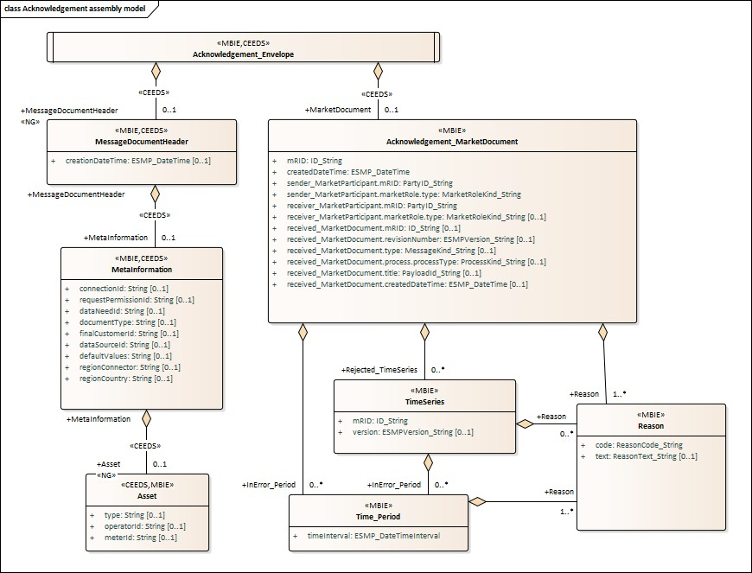

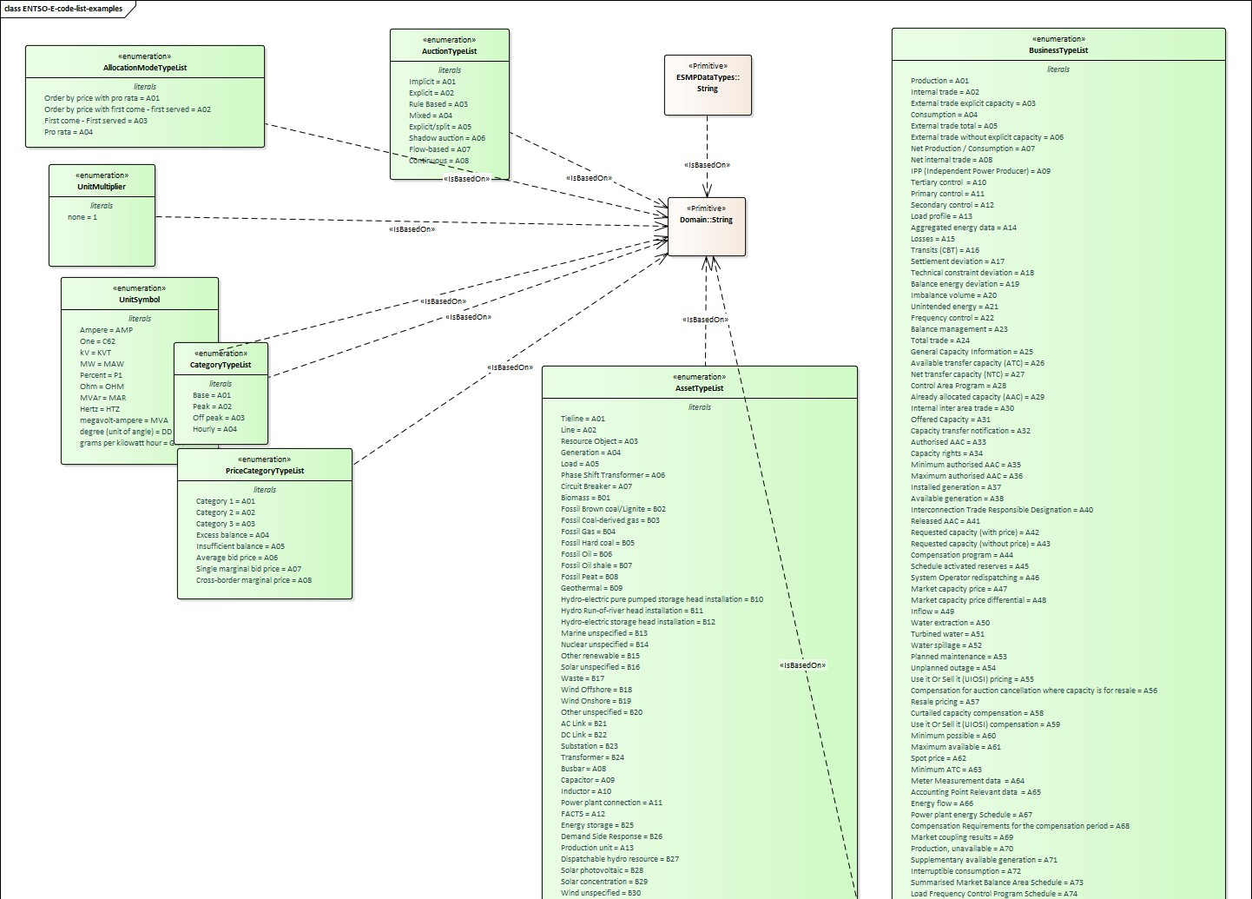

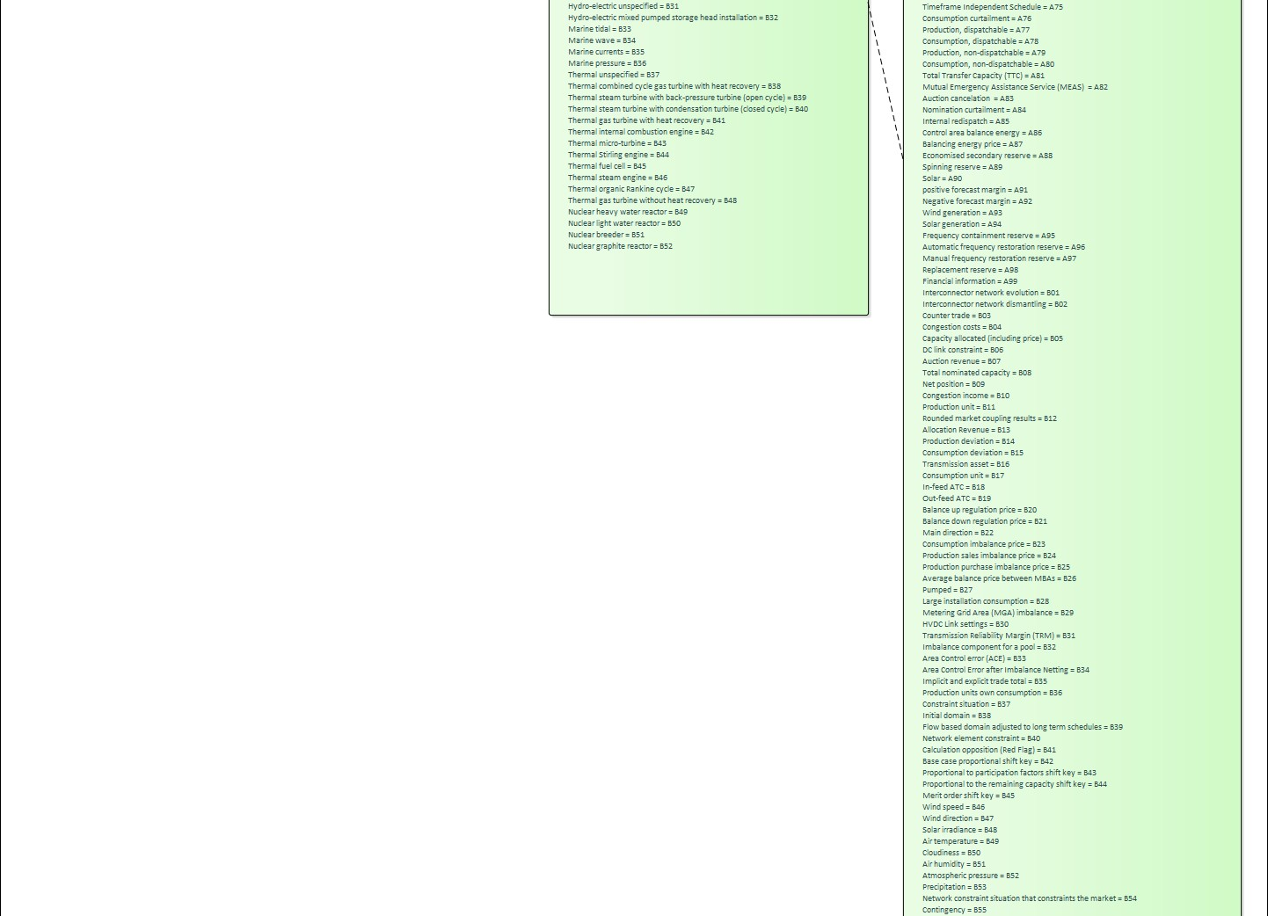





ESMPDataTypes_ESMPCompound.png %d×%d pixels
